Instruction for the preparation of a two-page abstract of a paper International scientific and practical conference "BUD-MASTER-CLASS-2025"
Name Surname, academic rank / degree, position ¹ (ORCID ID 0000-000X-XXXX-XXXX). Name M.Surname, academic rank / degree, position ² (ORCID ID 0000-000X-XXXX-XXXX)
¹ Name of Institution1, Country
² Name of Institution1, Country

ABSTRACT
This document provides the instruction of the preparation a two-page abstract of a paper that will be published in the BMC-2024 proceedings. The paper including figures, tables, and references should have exactly 2 pages. Papers which will not meet the formal requirements listed in the instruction will not be accepted. If you are not clear about any of the instructions or would like to get further information on formatting, please contact the Organizing Committee. The only reviewed and accepted papers will be published.
Keywords: geotechnical conference, retaining walls, foundation, numerical methods, earthquake, geology, glacitectonic

INTRODUCTION
This is an instruction for authors which is written in the required form of a two-page paper for the BMC-2023. The paper is expected to be written in grammatically correct and easily readable way. Recommended language is English. Usage of English and Ukrainian is allowed.

FORMAT
The paper has to be wrote on paper size A4 (21.0 cm/29.7 cm). Text should be produced within the following dimensions: each column 8.2 cm wide with 0.6 cm middle margin, total width 17.0 cm and a maximum length of 23.5 cm. Paper margins must be equal on both sides and equal on the top and bottom. Keep the stipulated length apart from the following two exceptions:
- do not begin a new section directly at the bottom of a page, but transfer the heading to the top of the next column;
- you may exceed the length of the text area by one line only in order to complete a section of text or paragraph.
The usual text must be written with letter size 9 pt and single spacing. The font used must be Times New Roman. Paragraph or block of text should be justified. Paragraphs should have 5mm indentations. The words figure, equation and reference have to be abbreviated as Fig. 1, Eqn (2) and Ref. [3], unless they appear as the first word of a sentence. In this case they should be typed in full as Figure 1, Equation (2) and Reference [3]. When a problem is studied in a number of references, one can also refer to them by recalling [1,2,3]. The author should take much care to make two-page abstract of a paper shorter, clearly demonstrating the novelty of idea.

Title
The title should be written in 12 pt boldface letters and centered. It begins 3.5 cm below the upper edge of the sheet. The title should be short and adequately reflect the paper contents. If a title is more than one line long, the lines of the title should be in single spacing. The title should not be longer than 130 characters with spaces. The font used must be Times New Roman.

Author
The author’s name should include first name, middle initials (if any) and surname. The name(s) should be centered and 9 pt boldface letters should be used. The single space should be between the last text line of the title and the first text line of the author’s name.

Affiliation
The author’s affiliation should be written in 9 pt italic letters and centered. In case of many affiliations they may be numbered consecutively. The font used must be Times New Roman.

Abstract
The abstract (max. 10 lines) text must be written with letter size 9 pt and single spacing. The font used must be Times New Roman.

Keywords
Keywords should be written in 9 pt italic letters. The font used must be Times New Roman.

Headings of sections
The headings should be written left aligned. The main headings should be written in 9 pt boldface letters and the secondary headings in 9 pt italic letters. The font used must be Times New Roman.

Spacing
We normally recommend the use of single line spacing. However, when typing complicated mathematical text it is important to increase the space between text lines in order to prevent sub- and super-script fonts overlapping one another and making your printed matter illegible.

TABLES AND FIGURES
Tables and figures should be arranged within the text and placed close to their text reference. One single line should separate a table or a figure from the caption.

Tables
Tables should be presented in the form shown in Table 1. Their layout should be consistent throughout. If tables do not fit into one column they may be placed across both columns in which case place them at the top or at the bottom of a page.
The name of a table should appear above it. Captions should be numbered sequentially starting with number 1.

Table 1: Margins
 | Page |  | Indentation
 | cm | mm | cm | mm
Left | 2 | 20 | 0.5 | 5
Right | 2 | 20 | - | -
Top | 3 | 30 | - | -
Bottom | 3 | 30 | -

Figures
All figures should be clearly displayed by leaving at least single line of spacing above and below them.
All notations and lettering should be no less than 2 mm high. The use of heavy black, bold lettering should be avoided, as this will look unpleasantly dark when printed.
The name of a figure should appear below it. All figures must be numbered sequentially starting with number 1. Please ensure that all spelling and annotations (numbers, letters, symbols and captions) conform to their usage in the text.

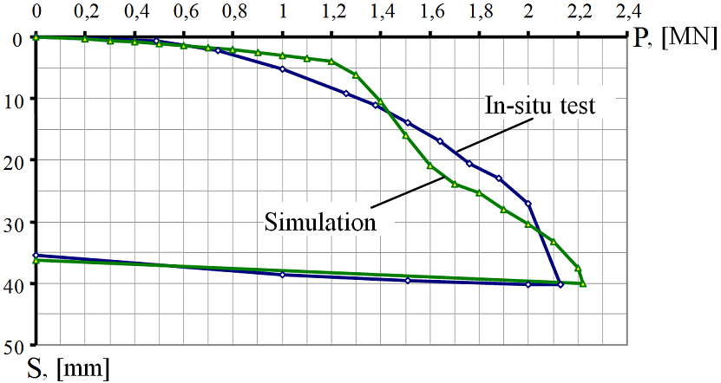
Figure 1. Simulation results of the axial compressive pile test

Colour figures cannot be included in their original form and will be reproduced in black and white or grayscale. High resolution figures in black and white are preferable.

EQUATIONS
Equations should be left aligned and should be proceeded and followed by a 3 pt vertical space.
$e_{i}=e_{0}−C_{0}⋅\text{ln}\left(\frac{P}{P_{0}}\right)$, | (1)
where P, P₀ – is current and initial compression pressure.
If the formulas are numbered, make sure that they are numbered consecutively. Place the numbers in parentheses flush with the right-hand margin of the column and level with the last line of the equation. Please ensure that subscripts and superscripts are clearly legible. The meaning of the variables used should be given or clear from the context.

PAGE NUMBERS
Pages of the paper must not be numbered, they will be numbered consecutively later by the editors of BMC 2023.

References
The references given above are examples of the following types: 1) paper in a journal, 2) paper in a conference proceedings, 3) book. 1. The Reference must be prepared in standard АРА (http://www.apastyle.org/). Each item in the list of references should be referred to in the text and quoted with numbers enclosed in brackets [1], [2], [3]. The text should be adjusted to the left margin, the second line and the following line with a 5mm indentation.
If two-page abstract is written in Ukrainian language the «ДСТУ ГОСТ 7.1:2006» and «ДСТУ 8302:2015» must be used to format the references.

[1] Lambe, TW. (1958). The structure of compacted clay. Journal of the Soil Mechanics and Foundation Engineering Division, ASCE 84: 1-34 .
[2] Boyko, I., Sakharov, O., Sakharov, V. (2013). Behavior of the multistory building under seismic loads with the account of the viscoplasticity of the soil base, Proceedings International Conference on Soil Mechanics and Geotechnical Engineering, Paris, P.1443-1446.
[3] Craig, R.F. (1999). Soil Mechanics (6th ed.). London: Spon Press.
[4] SkochkoV. I., Ploskyi V. O. Morphogenesis and adjustment of flat rod structures [Текст]. USEFUL. Online Scientific Journal. USA, Miami. Volume 2, Issue 2, 2018. pp. 8-26. DOI : https://doi.org/10.32557/useful-2-2-2018-0002.
[5] Sommer H., Katzenbach R, DeBenedittis Ch. 1990. Last-Verformungsverhalten des Messeturms Frankfurt. Vortrage der Baugrundtagung: Karlsruhe, Main.
[6] Pidlutskyi V., Boyko I., Nosenko V. 2017. Research of the interaction of piles with different lengths and the grillage in the foundations of high-rise buildings. Civil and environmental engineering reports CEER. Poland. №26 (3): 59-68. https://doi.org/ 10.1515/ceer-2017-0035.
[7] Boyko I.P. 2006. Peculiarities of the interaction of pile foundations under high-rise buildings with their foundation. Basics and foundations: Interdepartmental scientific and technical collection No. 30: 3-8.

* Partial filling of the last page by less than 80% is not allowed, and in case of inconsistency, theses will be rejected by the editorial board for revision.

